Application Form

The L’OCCITANE Foundation launches a call for projects to fight avoidable blindness and encourages L’OCCITANE offices worldwide to participate by identifying and supporting local organisations with eye care projects.

Calendar of application

- February 28th, 2021 : Application deadline
- April 2021 : Announcement of the supported projects
- Starting April 2021 : Signature of the partnership agreement between the local L’OCCITANE’s office, the L’OCCITANE Foundation and the local organization

Purpose

L’OCCITANE HAS BEEN CARING FOR SIGHT FOR +20 YEARS

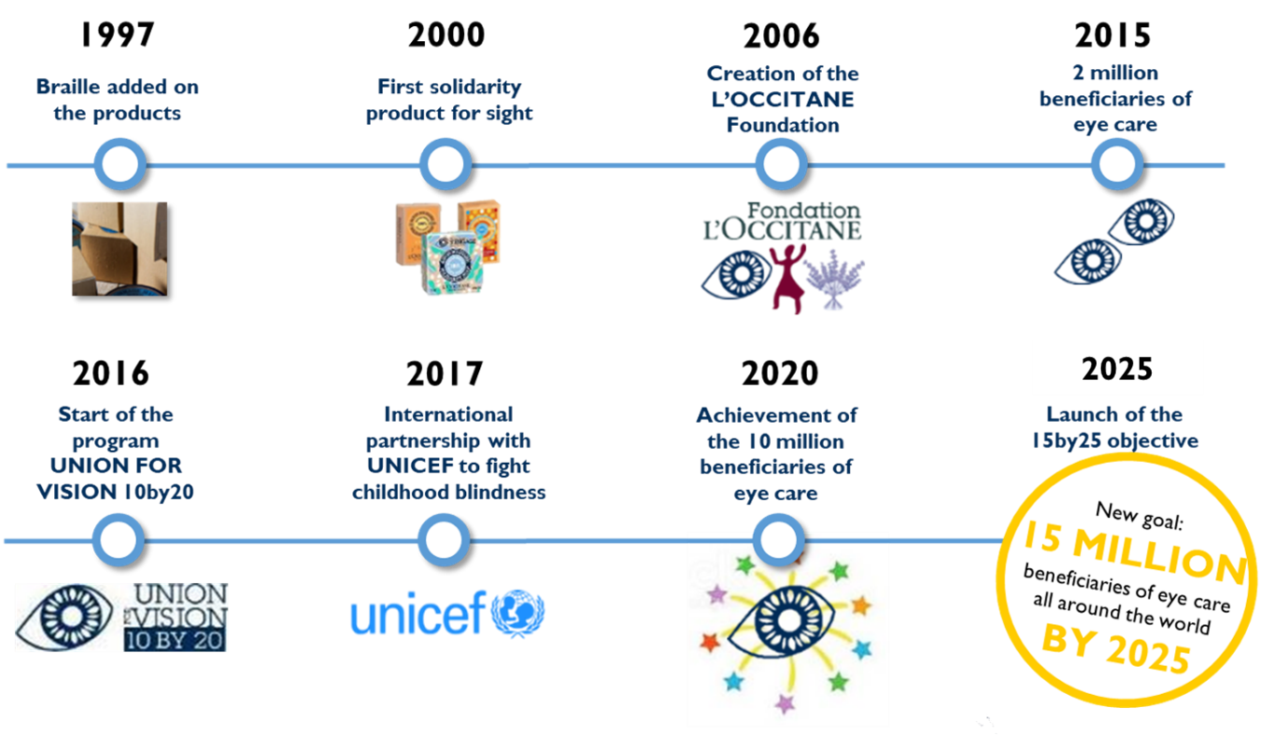

Rules & eligibility criteria

- The local project needs to be carried out by an organization of public interest.
- The project must focus on eye care (screenings sessions, provision of spectacles, treatments, surgeries, optometrists or ophthalmologists training, purchase of machinery and equipment, etc).
- The project needs to have measurable results. The number of beneficiaries receiving eye care thanks to the help of L’OCCITANE must be included in at least one of the lines of the table in 1.12 part of the following application form.
- A strong focus will be done on the sustainability of the project
- The LOCAL ORGANIZATION needs to be able to receive euros and international money transfer.
If all the eligibility criteria are validated, please contact the L’OCCITANE local office located in your country, or where the project is taking place, in order to present your structure and project.

NB - If you are unable to contact the local L'OCCITANE branch, you can contact caringforsight@loccitane.com. The call for projects being based on the commitment of a local subsidiary of L'OCCITANE, the probability that your project is selected will be very low if you apply directly, without the accompaniment of a subsidiary company.

Financial support

The projects are co-funded by L’OCCITANE’s local offices and by the L’OCCITANE Foundation.
Depending on the location, the average requested grant should be around:

TOTAL RECOMMENDED SUPPORT  FOR THE NGO / PROJECT |  | TOTAL RECOMMENDED SUPPORT  FOR THE NGO / PROJECT |  | TOTAL RECOMMENDED SUPPORT  FOR THE NGO / PROJECT
+/- 30K€ |  | +/- 20K€ |  | +/- 10K€
= |  | = |  | =
RECOMMENDED  MINIMUM DONATION  FROM THE L'OCCITANE'S  LOCAL OFFICE |  | RECOMMENDED  MINIMUM DONATION  FROM THE L'OCCITANE'S  LOCAL OFFICE |  | RECOMMENDED  MINIMUM DONATION  FROM THE L'OCCITANE'S  LOCAL OFFICE
20K€ |  | 10K€ |  | 5K€
+ |  | + |  | +
THE FOUNDATION  ALSO PROVIDES  FINANCIAL SUPPORT |  | THE FOUNDATION WILL DOUBLE  THE L'OCCITANE LOCAL OFFICE'S DONATION |  | THE FOUNDATION WILL DOUBLE  THE L'OCCITANE LOCAL OFFICE'S  DONATION
IN THE LIMIT OF 10 k€ |  | IN THE LIMIT OF 10 k€ |  | IN THE LIMIT OF 5 k€
*********** FOR NGO and/or PROJECTS IN ***********
Australia |  | Austria |  | Albania | Greece | Myanmar
Brazil |  | Belgium |  | Argentina | Guadeloupe | New Caledonia
Canada |  | Czech Republic |  | Armenia | Guatemala | Nigeria
China |  | Finland |  | Azerbaijan | Honduras | New Zealand
France |  | Hungary |  | Belarus | Iceland | Panama
Germany |  | India |  | Bolivia | Indonesia | Paraguay
Hong Kong |  | Ireland |  | Bosnia | Israel | Peru
Japan |  | Italy |  | Bulgaria | Kazakhstan | Philippines
Korea |  | Macau |  | Chile | Kenya | Reunion
Malaysia |  | Mexico |  | Colombia | Kosovo | Romania
Russia |  | Netherlands |  | Costa Rica | Kyrgyzstan | Serbia
Taiwan |  | Norway |  | Croatia | Latvia | Slovenia
UK |  | Poland |  | Cuba | Lithuania | South Africa
USA |  | Portugal |  | Cyprus | Macedonia | Tahiti
 |  | Singapore |  | Dominican Rep | Malta | Tunisia
 |  | Slovakia |  | Ecuador | Martinique | Turkey
 |  | South Africa |  | El Salvador | Mauritius | Ukraine
 |  | Spain |  | Estonia | Middle East | Uzbekistan
 |  | Sweden |  | Georgia | Mongolia | Venezuela
 |  | Switzerland |  | Ghana | Morocco | Vietnam
 |  | Thailand

Summary

Name of the project:
Organization running the project:
Country of the project:
Dates of the project (from XX/XX/XXXX to XX/XX/XXXX):
Summary of the project (three lines maximum):

Total requested grant (in €):

The organization

Name of the organization

Field of action / Specialty of the organization

Type of organization and global mission
3 lines max

First name and surname of the legal representative

Key funding sources of the organization
3 lines max

Number of years in operation

E-mail

Phone number

Does it have an office in France or in Europe?

The project
- Presentation

1.1 Name of the project

1.2 Description
5 lines max

1.3 Location of the project

1.4 Duration of the project

1.5 How is your project answering a need of public interest?
3 lines max

1.6 Global context (geographic, politic, economic, social …)
5 lines max

1.7 Does the project is part of a bigger program ? Which one ?
3 lines max

1.8 Detailed project description. What activities will you carry out?
15 lines max

1.9 How is this project different from other projects that have already been done in the country ?

How is this innovative compared to other projects in this field of action ?
5 lines max

1.10 Goals / Results expected

1.11 Means implemented to measure the expected results and impacts

1.12 Number of beneficiaries who will receive eye care thanks to the help of L’OCCITANE:

1/ Please note that we are interested by the number of people who received eye care and not the number of eye care they receive: A beneficiary who has benefited from more than one eye care (for example, screening and treatment or surgery) must not appear twice in the table/should not be counted twice).

2/ If your organization has been supported by L’OCCITANE in the past, please apply for a project with new beneficiaries (in another geographical area, new target population, etc.) / the beneficiaries need to be different from the previously supported projects.

 |  | CHILDREN  < 18 years old | ADULTS | TOTAL
1 - During the funded period (ie. “year 2021”)
NUMBER OF BENEFICIARIES SCREENED |  | ..….. | ..….. | ..…..
 | Among the total number of beneficiaries screened,  number who received treatments | ……. | ……. | …….
 | Among the total number of beneficiaries screened,  number of beneficiaries who received surgeries | ……. | ……. | …….
 | Among the total number of beneficiaries screened,  number of beneficiaries who received prescriptions glasses | ……. | ……. | …….
NUMBER OF MEDICAL STAFF TRAINED |  |  |  | ..…..
NUMBER OF MACHINE(S) BOUGHT |  |  |  | ..…..
2 - After the funded period (ie. “Years 2022 + 2023 +2024 + 2025”)
NUMBER OF FUTURE BENEFICIARIES BY 2025 (INCLUDED)  THANKS TO THE FUNDED TRAINING and/or MACHINE  Ex: if you estimate that 1 medical staff trained screens 50 patients per year,  he /she will screen 50 people x 5 years = 250 beneficiaries in 5 years (from 2021 to 2025)  Ex: if you estimate that the machine bought will allow the screening of 300 patients/year, it means that 300 people x 5 years = 1 500 beneficiaries in 5 years (from 2021 to 2025) |  | ……. | ……. | .…..
1 + 2 = total during the funded period + after the funded period (ie. From 2021 to 2025)
TOTAL NUMBER OF BENEFICIARIES SCREENED DURING THE FUNDED PERIOD + NUMBER OF FUTURE BENEFICIARIES BY 2025 THANKS TO THE FUNDED TRAINING AND/OR MACHINE(s) |  | ……. | ……. | ..…..

- Projected calendar of the actions for the year

Please, insert your calendar / action plan
HERE

2.1 Risks that might modify the calendar
5 lines max

2.2 Forecast actions to face them
5 lines max

- Project sustainability

3.1 Continuation & sustainability of the project
5 lines max

3.2 Relationships with local partners, national authorities and other programs
5 lines max

3.3 Fallback strategy & project autonomy
5 lines max

3.4 Self-financing long term strategy
5 lines max

3.5 Scalability
3 lines max

3.6 Does your project take into account the impact of the environment?
3 lines max

Budget
Amount (in €)
Total project’s budget
Total L’OCCITANE’s requested grant
Other funding / financial support

Please note that the grants will be transferred between the 1st of April 2021 and the 31st of March 2022

- Please insert your project’s detailed budget in €

(With the detailed expenses / explain how L’OCCITANE’s requested grant would be used for)

Activity/Detailed Items | Details of Cost Estimates
 | Unit Cost (€) | Basis of Calculation | Unit | Total budget (€)
 | - € |  |  | - €
 | - € |  |  | - €
 | - € |  |  | - €
 | - € |  |  | - €
 | - € |  |  | - €
 | - € |  |  | - €
TOTAL REQUESTED GRANT |  |  |  | - €

- Do you have others public or private funders involved for this project?
If so, please list them

Communication

Please insert your logo
Here

Please insert some pictures of the project (if you already have some) or of some other similar project:
Here

Communication actions planned around the project & L’OCCITANE and its Foundation:
5 lines max

L’Occitane’s local office
To be filled by the local L’OCCITANE office

Which L’OCCITANE’s office will be involved in the project?
Name and country
Number of employees in the L’OCCITANE’s office

Number of employees that will be involved in the project

Who will be responsible for the project follow up?
name, title, email, phone number

How much is the local L’OCCITANE office’s budget to support the project?
Local budget in euros (without the L’OCCITANE’s foundation co-founding)

